CE1140: Environmental Sustainability and the Earth’s Climate
A new objective 5 course Time: Fall semester 2024, MWF 9-9:50 AM. Place: Rendezvous 111.

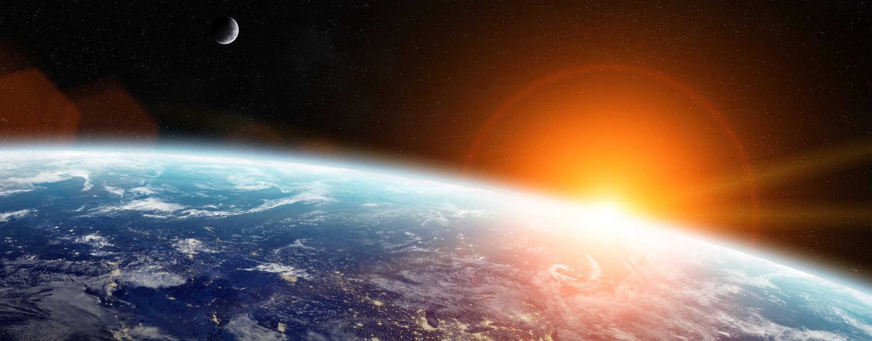

This course presents a broad overview of the science of climate change including its possible causes, as well as societal and environmental impacts. It examines environmental sustainability, future climate projections, societal decisions that may influence future greenhouse gas emissions, possible mitigation strategies, and our ability to adapt to climate change. 3 credits.
Group taught by civil engineering (Sato), electrical engineering (Ellis), physics (Dale), and philosophy (Rodriguez).

