New Requisition Approval Queue
Old Method of Approval:
- The Approval Alerts Channel is connected to a Banner Self Service 8 release page, which has been updated to release 9. With the updated release several functions in Banner Self Service will change.
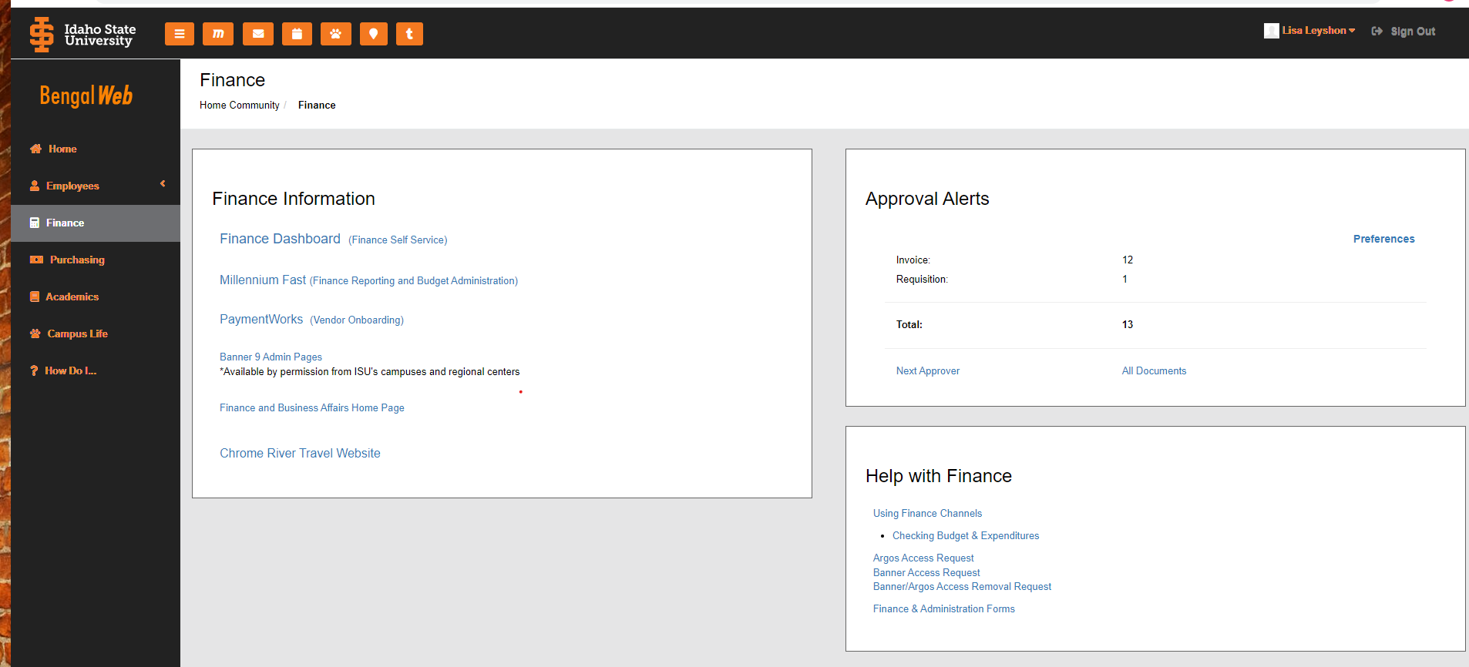

New Method of Approval:
- In order to approve requisitions account directors, UBO’s and grant accounting will need to access the approval queue through the Finance Dashboard.
- Click on Finance Dashboard in the Finance Information Channel on the Finance Tab in Bengal Web. This will take you to the My Finance page in Banner Self Service.
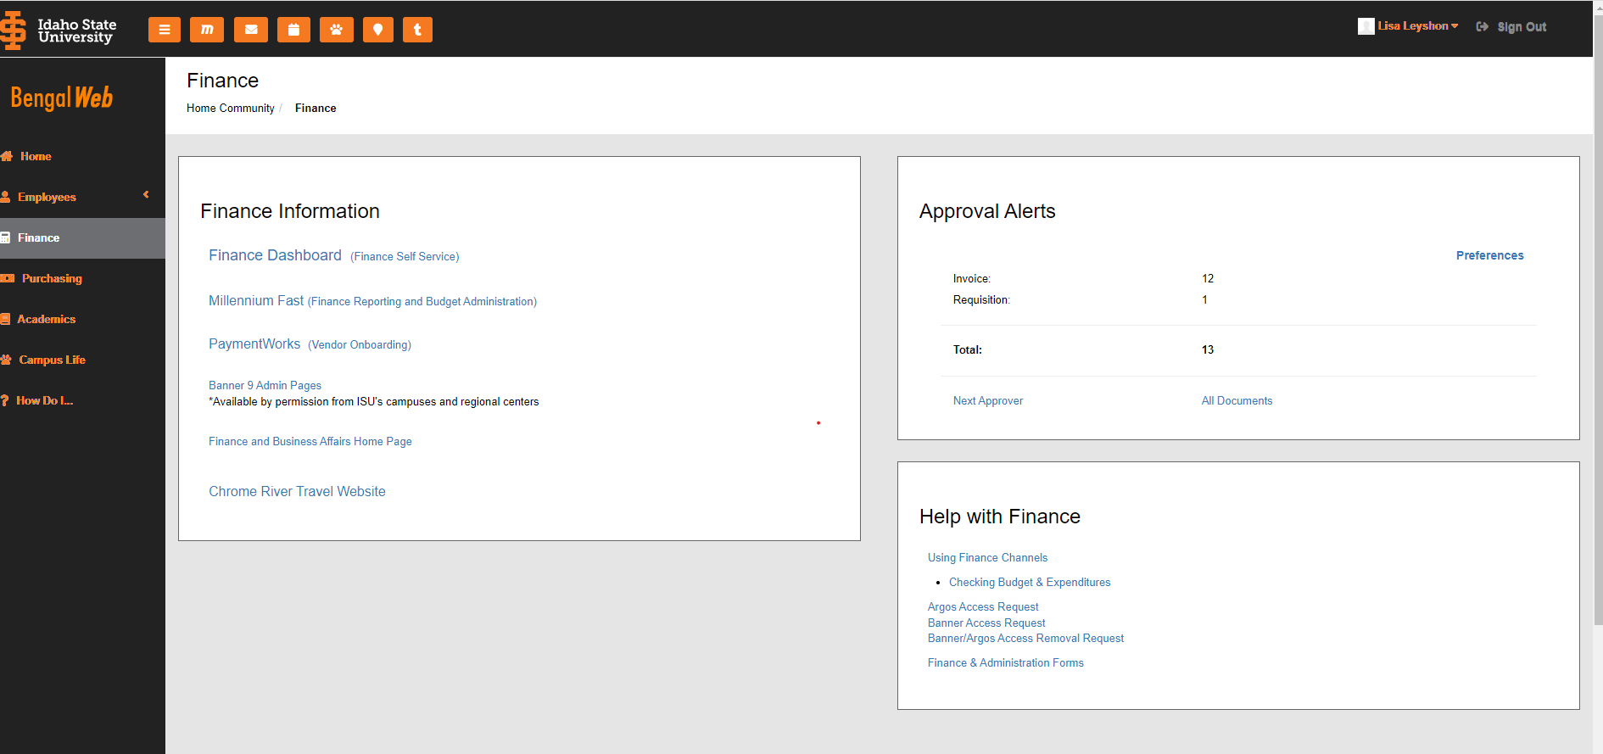

- Click on Approve Documents
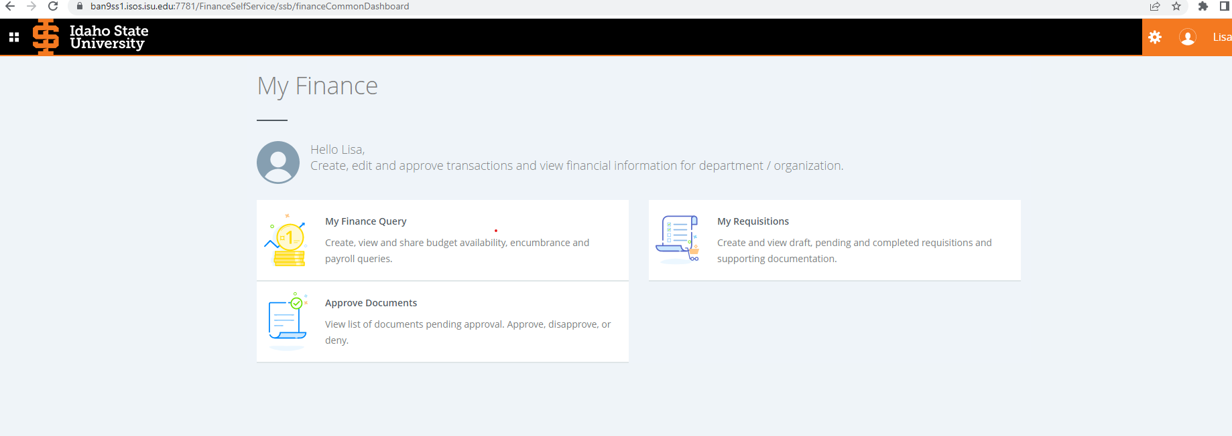
- Your User ID will appear in the User ID field
- Choose either “User ID is next approver” or “All documents User may approve”
- Click submit

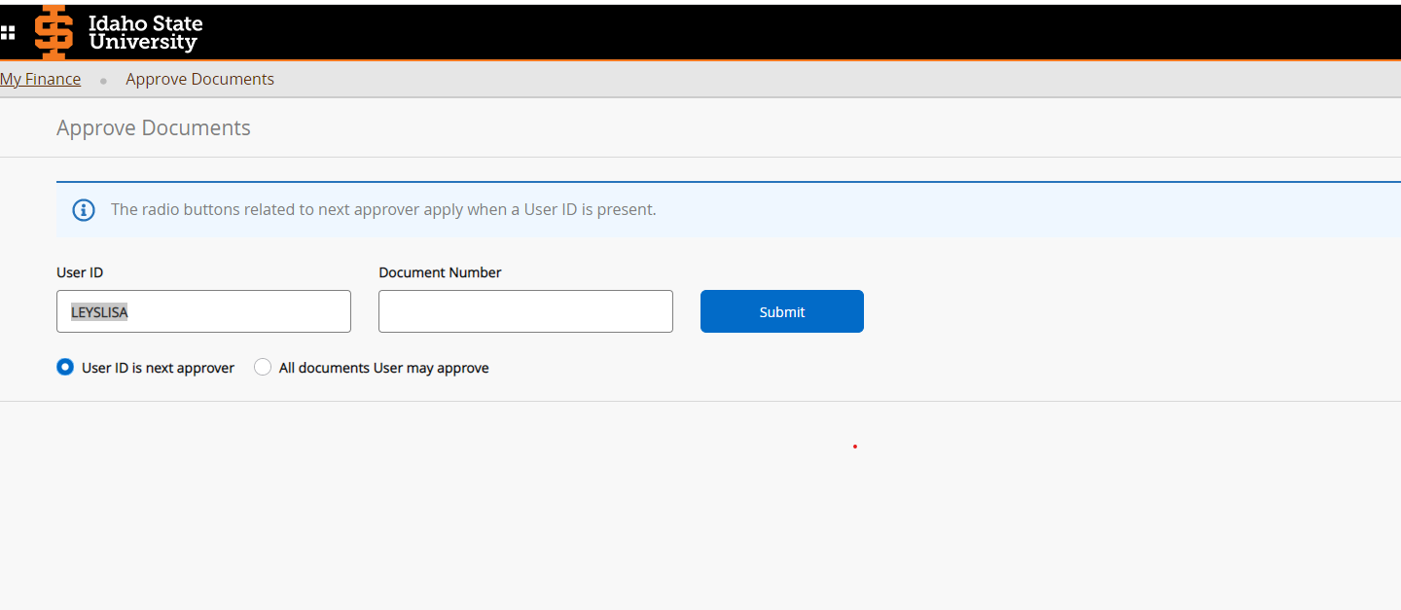
- All Documents waiting for your approval should be listed.
- Click on the document number to review the document information.
- To view other approvals, click on history
- Select Disapprove or Approve

