The Department of Chemistry’s Information Session

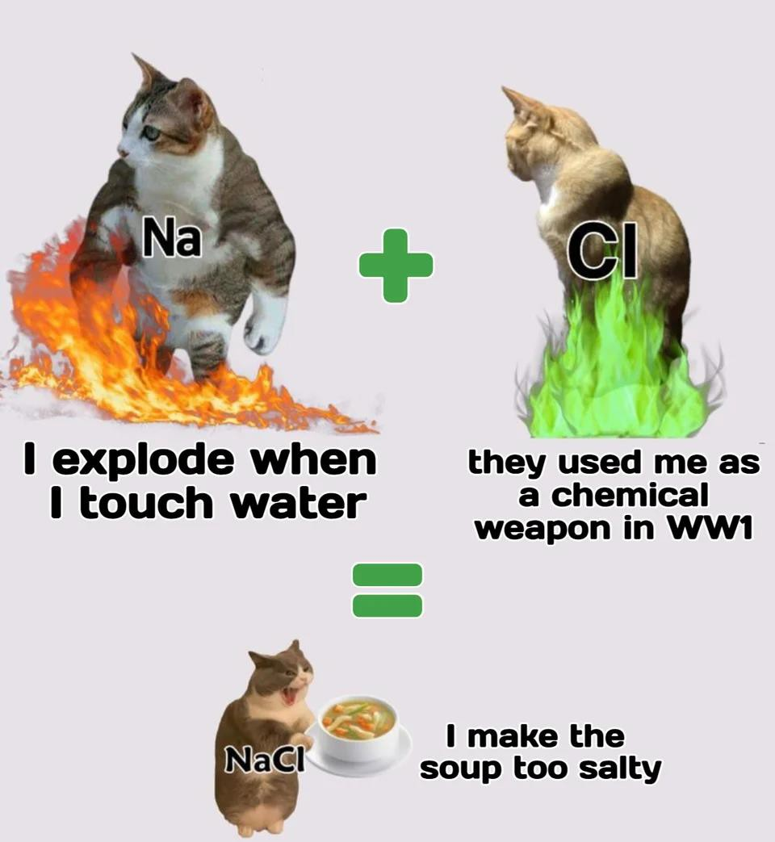
- We will cover:
  - Why you might want to be a
(Bio)Chemistry major/minor
  - Related career options
  - Our degree programs
  - How to get involved in research
  - Chem Club!
  - Scholarships! (Free money!)
  - Graduate programs and when to
plan!

First and second year students:
What do you want to know about (bio)chemistry degree?

Third, fourth (and beyond) year students:
What do you wish you had known earlier about (bio)chemistry degree?

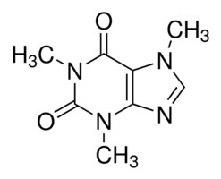
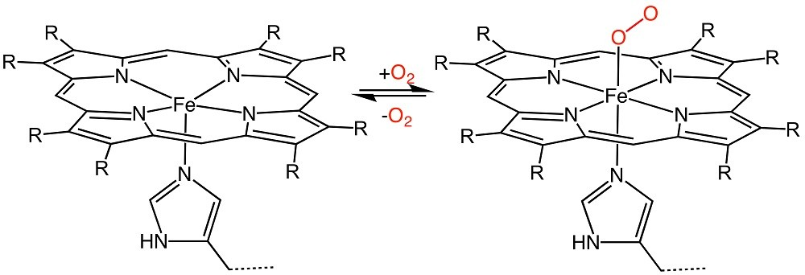
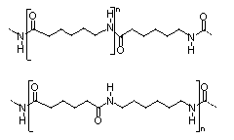

Why Biochemistry or Chemistry?
The study of the chemistry of life
The study of matter’s composition, properties
and reactions.
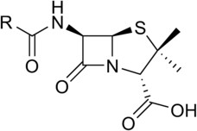

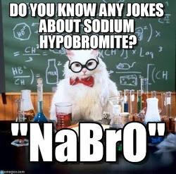

Biochemists and Chemists are in demand and are paid well.

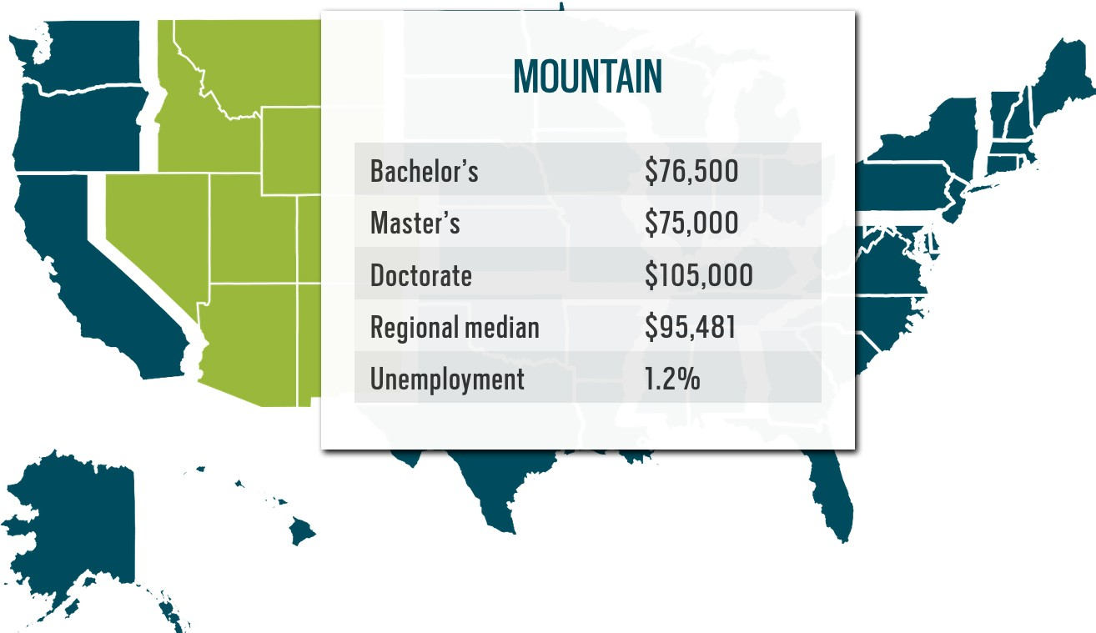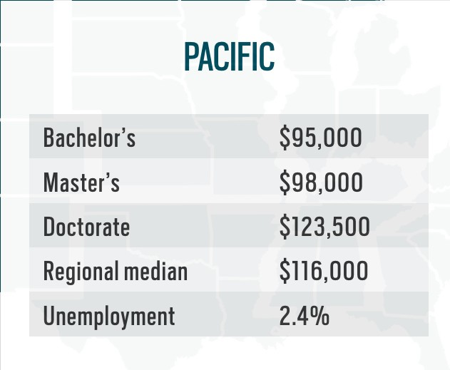

What you can do as a (Bio)Chem major

1. Take awesome classes
3. Can apply to ...

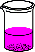
Learn how and
why (Bio)Chem works!
Discover why
Science is
awesome!

Hang around with like-
2. Get involved
minded people
Do awesome demos with ChemClub
Join a research lab Get help/advice with classes, homework, etc.
Inspire youngsters with chemistry knowledge Get to know faculty
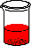 Graduate schools: Chemistry, Biochemistry, Molecular Biology, Microbiology, etc.
Professional schools: Medical,
4. …or get a job
Veterinary, Dental,
Nursing, PA, etc.

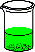 Government labs: INL,
Pocatello crime lab, etc.
Industrial jobs:
Simplot, Amy’s Kitchen, Medaluca, Micron, etc.
Biotechnology
companies:ARUP Industries, BioFire/Biomerieux, Cytozyme Laboratories, etc.

What do chemists and biochemists do in their careers?

Measure chemical quantities:

Make chemical compounds:

Manage chemical information: Communicate chemical ideas:
Industrial manufacturing Public Health
Law Enforcement
Pharmaceutical Industry Electronics Manufacturers Agrochemical Companies
Laboratory Management Regulatory Compliance
Teaching
Technical or Science Writing Law and policy
Marketing

Degree programs and Opportunities for (Bio)Chemistry Majors
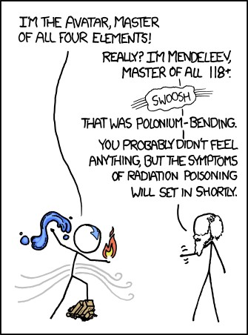
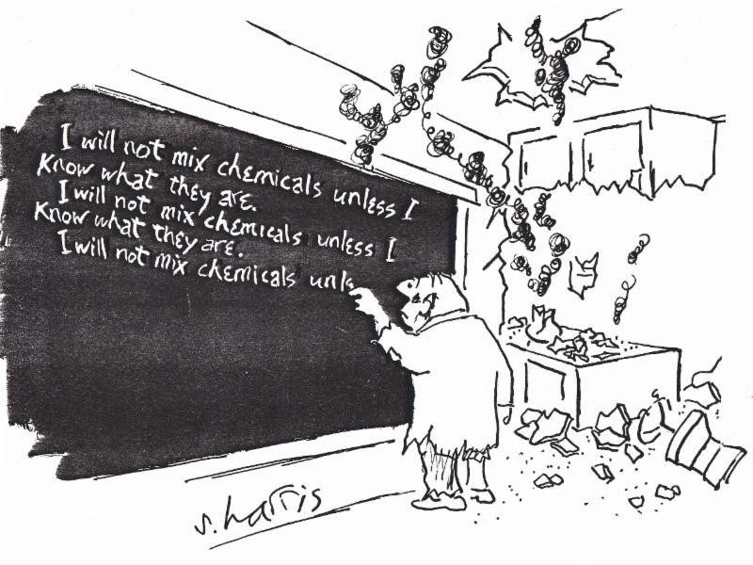

Undergraduate Degrees at ISU

Minor in Chemistry
  - BS in Chemistry
  - BA in Chemistry (more flexibility, less calculus)
  - BS in Biochemistry
  - Accelerated BS/MS in Chemistry
    - Apply by April 1st as sophomore for funding consideration
    - Earn BS and MS degrees in 5 years total

Questions about any degree program? Ask your chemistry instructor or a chemistry advisor!

Scholarships @ ISU CHEM
www.isu.edu/chem/student-resources/scholarships/

- Chemistry/Biochemistry Scholarships at ISU (Deadlines in Spring)
  - Chemistry Endowment Fund
  - Pattie Family Scholarship
  - Kasiska Health Science Scholarship

More scholarship information at www.isu.edu/scholar/list_scienceandengineering.shtml

Other National Scholarships & Fellowships
  - American Chemical Society Scholars Program
  - American Indian College Fund
  - Barry M. Goldwater Scholarships
  - Environmental Protection Agency Fellowships
  - Hispanic Scholarship Fund Scholarship Opportunities
  - Knowles Science Teaching Foundation (KSTF) Science & Mathematics Teaching Fellowships
  - NASA Aeronautics Scholarship Program
  - National Institutes of Undergraduate Scholarship Program
  - Naval Research Enterprise Internship Program (NREIP)
  - NSF Developing Global Scientists and Engineers

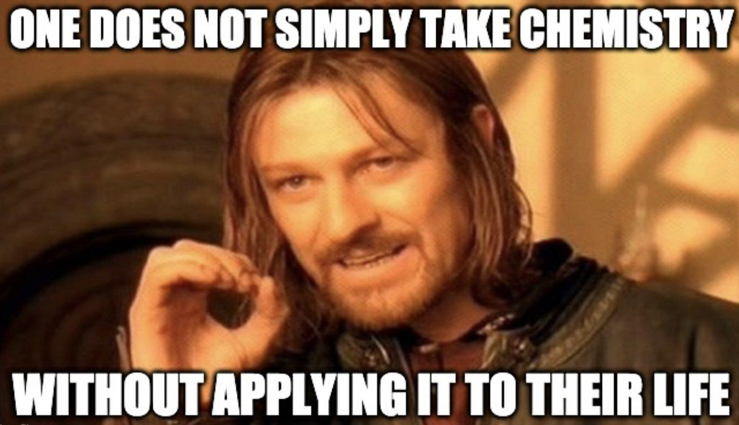

Other than taking classes and attending this event, what can you do at ISU to get more (bio)chemistry in your life?

Undergraduate Research

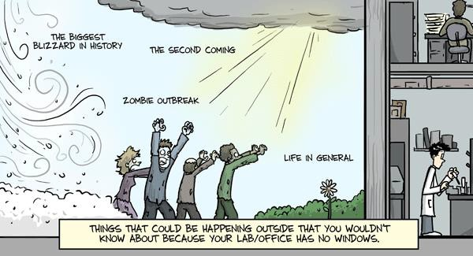

PhD comics: phdcomics.com/
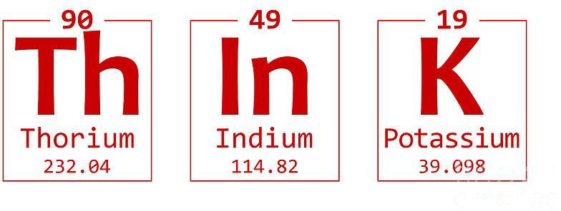

Finding Research Opportunities

Fall is good time to start looking for summer research opportunities!

Where to look:
Labs at ISU: Research Showcase (Wed. Sept 14, 6
pm). Also, look at faculty webpages and talk to instructors to find research that interests you.
Internships/Jobs: Job fairs and company websites.
Other Schools: Research Experience for
Undergraduates (REU) programs.

Faculty Research Areas

Analytical: | John Kalivas, Jeff Rosentreter
Biochemistry: | Caryn Evilia, Cori Jenkins
Environmental: | Jeff Rosentreter
Inorganic: | Andy Holland, Cori Jenkins, Joshua Pak
Organic: | Leslie Nickerson, Joshua Pak, Andy Holland
Physical: | Lisa Goss, Rene Rodriguez
Materials: | Cori Jenkins, Andy Holland, Joshua Pak
Nuclear: | Lisa Goss, Cori Jenkins, Joshua Pak, Rene Rodriguez

Summer Research Fellowships @ ISU

Chemistry - Summer Undergraduate Research Fellowships
The Department of Chemistry gives several C-SURF awards for students to conduct part-time summer research. Deadline is second Monday in February. (5 awards of $2,500 in 2021 & 2022.)

IDeA Network of Biomedical Research Excellence (INBRE)
ISU awards summer paid fellowships ($7,200 for 10 weeks) for students pursuing biomedical research career. You can participate in research activities at all Idaho universities and colleges. (Application deadline early November 2022 for summer 2023.)

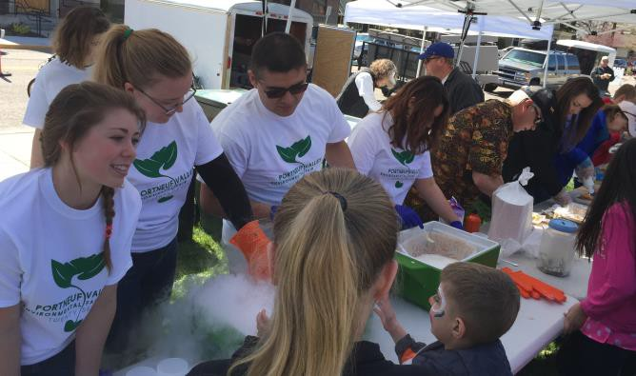
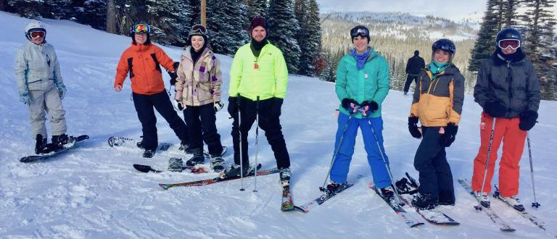
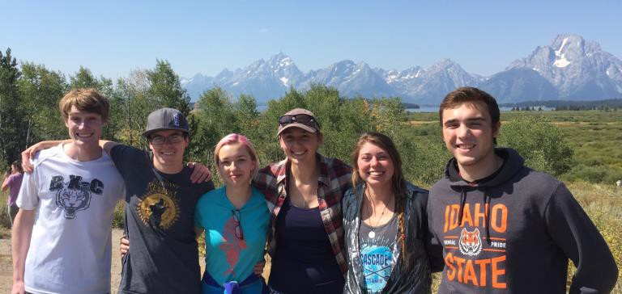
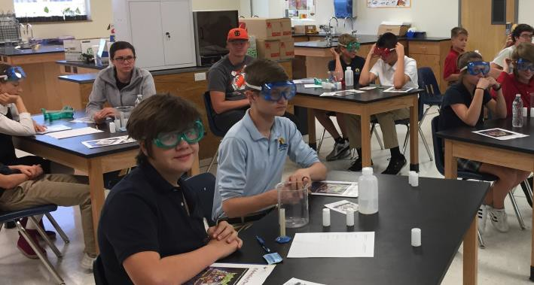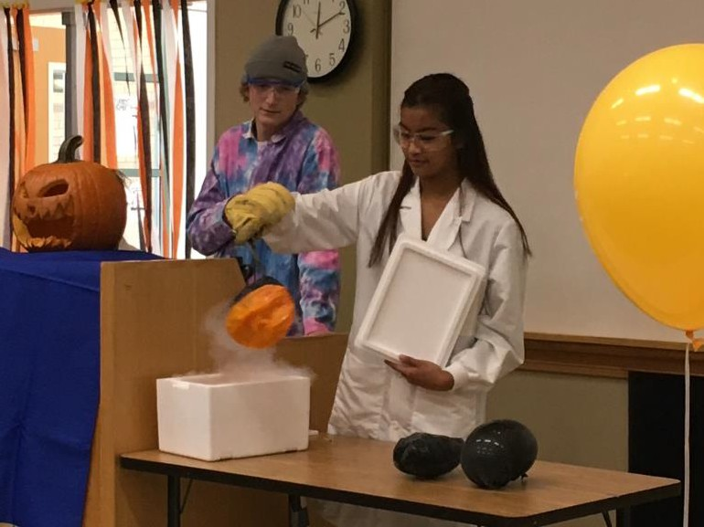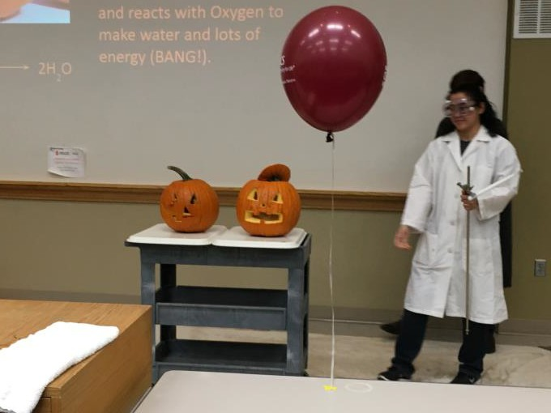

ISU
ChemClub

ChemClub – Be a part of the Solution!
Hang-out with like-minded people. Get help and advice on classes, science and more.
Try new & exciting reactions and demos.
Wow K-12 kids by performing demos and teaching Chemistry! Gain service and leadership experience.

Meetings (with free lunch!): Fridays 12:00-12:50 pm in Chemistry Study Room- PSC 248

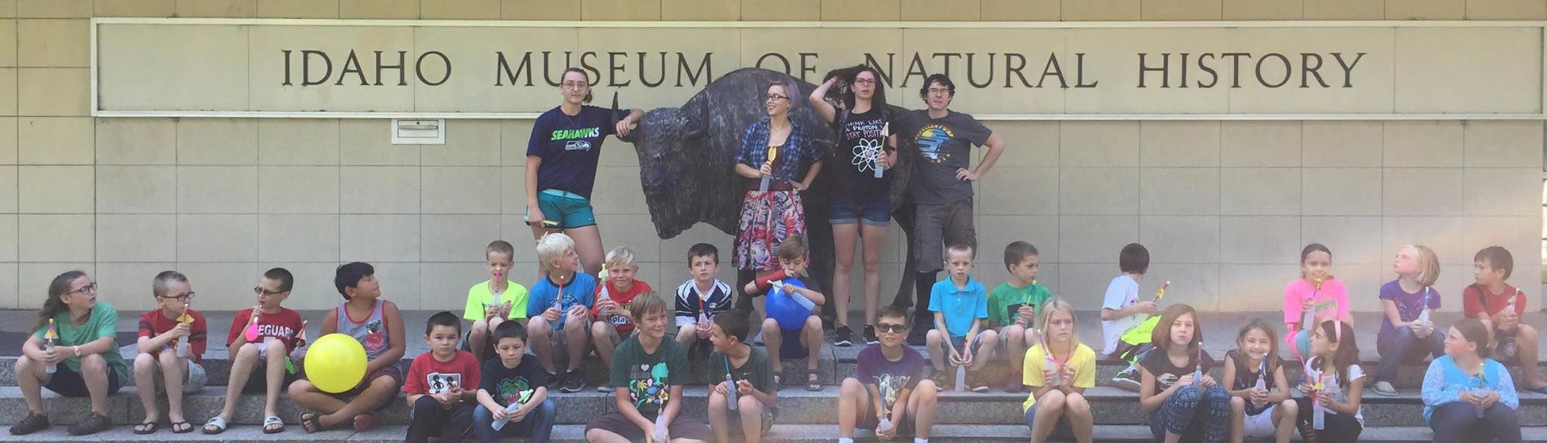

Other Opportunities for Involvement
- Experienced undergraduates are paid to TA introductory laboratory classes.

- Students are paid to assist the stockroom maintaining the facilities and preparing laboratory materials.

Talk to Dr. Pak to learn more about applying for these positions.

Now for all of the 3rd year students in the audience....

Graduate School – IT’S FREE!
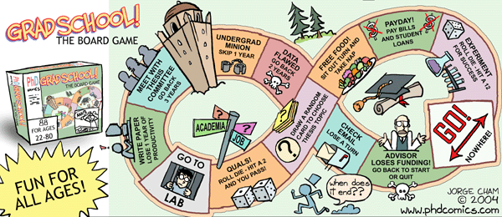

Graduate School
  - Ph.D. programs take 4-7 years, and center research alongside some coursework and teaching.
  - Graduate schools pay tuition/fees and a stipend (~$20K to ~$40K).
  - Additional fellowships are available to exceptional students (more
$$).
  - First application deadlines are usually in December.
  - Some programs accept applications as late as April.
  - All applications require personal statement, research statement, 3
letters of recommendation, transcript
  - Some require general GRE; fewer require chemistry GRE (take your first GRE in Nov – Dec)
  - Once accepted, you are invited for a paid visit.

What can I do now?

Know the deadlines and plan ahead!
- Compile a strong academic record.
- Gain research/service/leadership/teaching experiences. (such as ChemClub & STEMClub)
- Strive for scientific presentations and publications.
- Cultivate strong recommendations (get to know faculty members in your department/critical courses).
- Write clear and scientifically-sound essays that:
  - Link your teaching and research experiences.
  - Highlight any challenges and achievements.
  - Display your passion and motivation for your field of study.

Get Advised!

Questions for you!

Was this helpful?

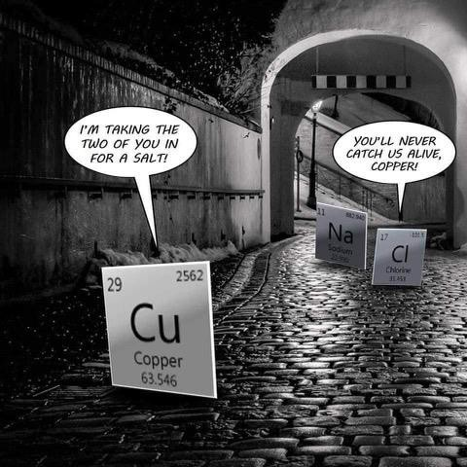
What other information would you like to see here?

Should we get something other than pizza?

Come to the Research Showcase!
- When: Wednesday, September 14th , 6 pm
- Where: Chemistry building atrium
- Why?
  - Meet faculty and students that are doing undergraduate research in the Chemistry department
  - Eat more pizza and ice cream!
  - Talk to Chem club about their exciting events!

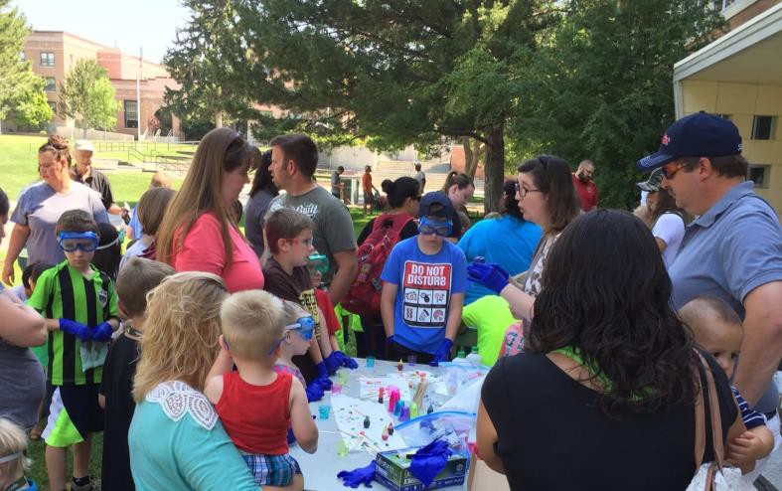

Thank you for coming!
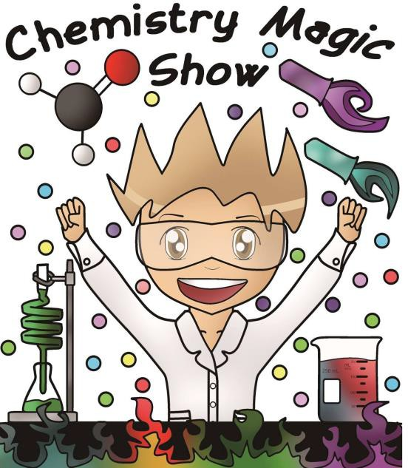
Questions?
