I D A H O S T A T E U N I V E R S I T Y E L E C T R I C A L E N G I N E E R I N G

Application for Admission to the Capstone Design Sequence

Date of Application:

Student Name (Print): ISU ID#:

Student ISU email address:

Student Signature:

Expected Graduation Date:

Advisor comments and/or special instructions to the student:

Advisor Approval Date

Date
Committee Review:
- Approved
- Denied
Review Committee comments and/or special instructions to the student:

The EE Capstone Design Sequence consists of two courses:

- EE 4495 Senior Seminar, a three-credit course offered only during the Fall Semester, and
- EE 4496 Project Design, a three-credit course offered only during the Spring Semester.

EE 4495 includes classroom discussion of current topics in Electrical Engineering, an in-depth written analysis of an EE-related current event, classroom discussion of ethics and professionalism, an in-depth written analysis of a recent professional/ethical dilemma encountered by industry in the news, preliminary project proposals, working group formation, development of full project proposals, and the initial stages of planning, budgeting, design and development activities associated with the final project.

EE 4496 proceeds with the conceptual design, analysis, and implementation of the multidisciplinary projects selected in EE 4495.

The sequence is offered once per Academic Year, and the two courses are intended to be taken in consecutive terms beginning with the Fall semester of the student’s final (Senior) year. Under no circumstances will an intervening semester be allowed while the student completes this sequence, nor will the order in which the courses are taken be changed. Once the sequence is begun in the Fall, it is intended that the student will complete all BSEE program requirements and graduate the following Spring. This includes any necessary remedial courses, General Education Objective courses, EE Core requirements, EE Electives and Technical Electives needed to satisfy published BSEE degree requirements.

Under special circumstances, if the student’s Plan of Study is out of phase with the normal four-year program, the student may take one extra semester beyond completion of this sequence to finish BSEE program requirements and graduate.

Every student eligible for the Senior Design sequence must submit an application before registering for EE 4495. Note that, since the sequence is offered only once per academic year, commencing with the Fall semester, students expecting to graduate in December must begin the Senior Design sequence in the Fall semester 15 months prior to graduation. Those expecting to graduate in the Spring must begin the sequence in the Fall semester 9 months prior to graduation. (Failure to meet these guidelines will result in delay of your graduation.)

In order to be considered for admission to the Capstone Design sequence.

- All EE core courses numbered less than 4000 must be successfully completed before beginning EE 4495. This means that all CHEM, CS, ENGL, MATH and PHYS pre- and-corequisite courses must also be completed.
- Submit a complete printed copy of your current DegreeWorks transcript. [Click on the “Save as PDF” button near the top of the page in DegreeWorks, wait until the document is created, then click on the printer icon at the top of the document window.]
- Submit a Plan for Degree Completion (form in this handout) outlining in detail your final two or three semesters – whichever is appropriate at the time you apply. This must be complete, and must show exactly how you will have fulfilled all of your degree requirements by your expected graduation date. This plan should be completed in consultation with your Assigned EE Program Advisor. Be sure to note the semesters when courses are actually offered, not when you wish they could be offered. The attached “flow chart” should help with this. Note that your EE Program

Advisor must approve your plan before your application will be considered by the Review Committee.
- Please submit these documents to the Engineering Office (LEL 218).

A Review Committee will examine and evaluate your application. When the committee has completed its review, you will be notified of its decision by email. If approved, the “Instructor Approval Required” registration block will be removed and you may register for EE 4495.

A copy of this application will be placed in your file once it has been approved. Note that this is a commitment on your part, and changes should be few and far between. If any are required, please make sure your EE Program Advisor approves of them.

An updated copy of this application will be required prior to admission to EE 4496. Although this may seem like a wasted effort, it will help you avoid any mistakes that may have serious unexpected consequences as your graduation date approaches.

2019-2021 EE Program Flow Chart
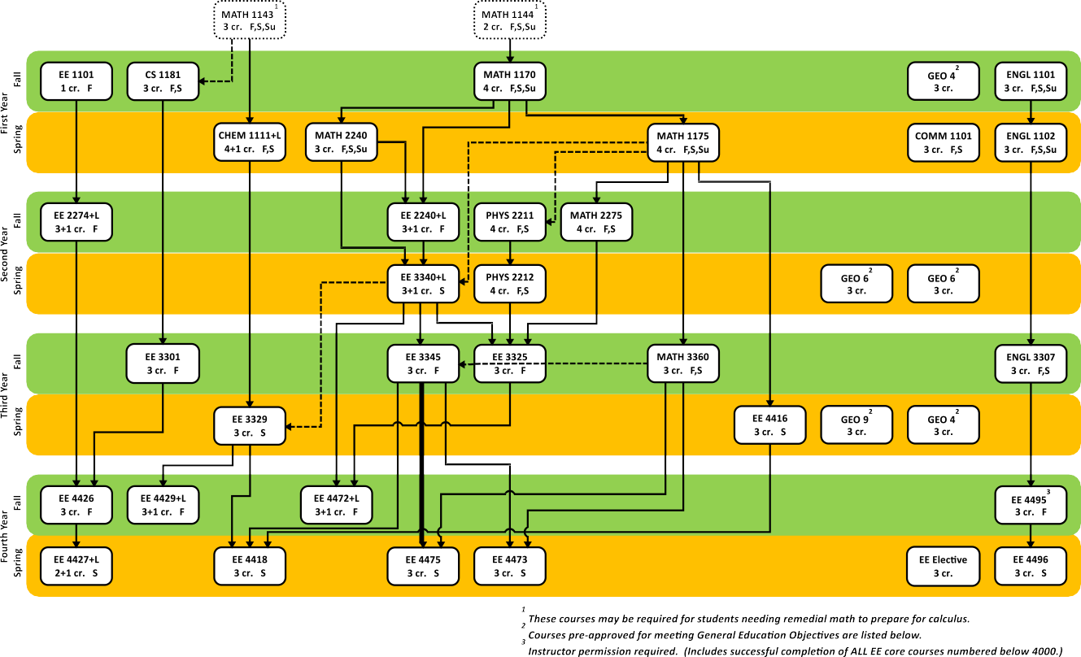

The four-year schedule shown above is for example purposes only. Spring courses may be rearranged between Spring semesters, and/or Fall courses may be rearranged between Fall semesters, to meet individual needs, so long as no attempt is made to switch a Fall course to Spring or vice-versa. If courses are moved, prerequisites and corequisites must still be satisfied in all cases.

GENERAL EDUCATION COURSES:
Objective 1: Satisfied with ENGL 1102 (must obtain a minimum grade of C-)
Objective 2: Satisfied with COMM 1101
Objective 3: Satisfied with MATH 1170
Objective 4: Take two of the following, selected from different categories (Humanities, Fine Arts, or Foreign Language): Humanities: ENGL 1110, 1115, 1126, 2257, 2258; HONS 1102; PHIL 1101, 1103
Fine Arts: ART 1100, 1101, 1102, 2210; DANC 1105, 2205; MC 2210; MUSC 1100, 1106, 1108, 1109; THEA 1101
Foreign Language: ANTH/ARBC/CHNS/FREN/GERM/JAPN/LATN/RUSS/SHOS/SPAN 1101, 1102; CSED 1151, 1152
Objective 5: Satisfied with CHEM 1111 & 1111L, PHYS 2211 & PHYS 2212
Objective 6: Take two of the following, selected from different prefixes: AMST 2200; ANTH 1100; CSED 2256; ECON 1100, 2201, 2202;
HIST 1101, 1102, 1111, 1112; POLS 1101; PSYC 1101; SOC 1101, 1102; WS 2201
Objective 7: Satisfied with CS 1181.
Objective 8: Not required if Objective 7 is met.
Objective 9: Take one of the following: ANTH 2212, 2237, 2238, 2239; CMLT 2207, 2208, 2209; CSED 2256; EDUC 2204; ENGL 2212;
HIST 2249, 2251, 2252, 2254, 2255; PHIL 2210; ANTH/ARBC/CHNS/FREN/GERM/JAPN/LATN/RUSS/SHOS/SPAN 2201,
2202

Plan for Degree Completion

TOTAL CREDITS
CREDITS
3
Fall Semester, Year

COURSE
EE 4495 Senior Seminar

TOTAL CREDITS
CREDITS
3
Spring Semester, Year

COURSE
EE 4496 Project Design

TOTAL CREDITS
CREDITS
Summer Semester, Year

COURSE

TOTAL CREDITS
CREDITS
Fall Semester, Year

COURSE

Note that failure to complete all graduation requirements within three semesters of the time you begin EE 4495 will necessitate your retaking the capstone design sequence.

