Lean Six Sigma Green Belt Certification

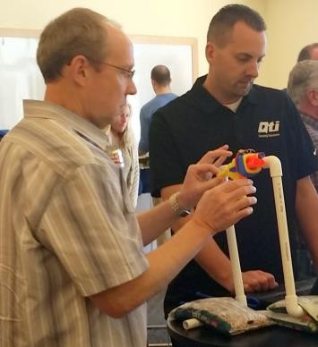  “Our goal is to be the best temperature sensor manufacturer in the world and Lean  Six-Sigma is what the best companies in the world are doing. We’ll keep doing it and  getting better; it’s a  never-ending journey”  Brandon Coleman Director of Engineering QTI Sensing Solutions | Lean Six Sigma (LSS) is a well-known approach for achieving operational excellence that does more than simply improve processes. LSS combines the process improvement benefits of Lean with the statistical process control (SPC) benefits of Six Sigma. It takes advantage of the “value-added” focus of Lean while maintaining the statistical rigors of Six Sigma. The course series includes four full-day training sessions with two weeks between sessions for participants to complete project work that is an essential part of the LSSGB program.  About the Course  - Participants learn the principles of Lean Manufacturing and Six Sigma using the DMAIC process.  - Experienced Lean Six Sigma practitioners teach the classes and support participants in their project work.  - Course material, simulations, and exercises are relevant to the regional organizatios.  - LSS project work allows the participant to apply class learning to an actual project in their organization.  - Successful participants receive a completion certificate from Idaho State University.  - Class size of 15 - 20 (max) ensures quality class time and project supervision.  - Course Fee: $1250 /person covers all sessions, training materials, project support, venues & food. There is a 10% discount for two or more people registering from the same company. ASQ members will receive a 10% discount.  - Registration: Visit http://isu.edu/cob/business-resources/leansixsigma/ to register for our upcoming course.  - Contact Dave O’Connell at DaveOConnell@isu.edu or 208.589.5567 for more information.

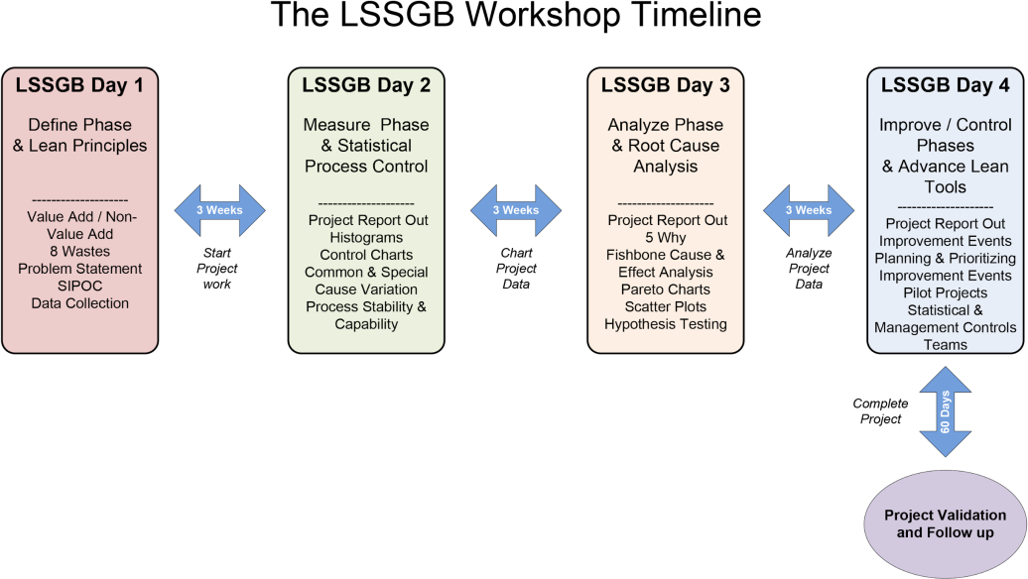

Lean Six Sigma Green Belt Curriculum

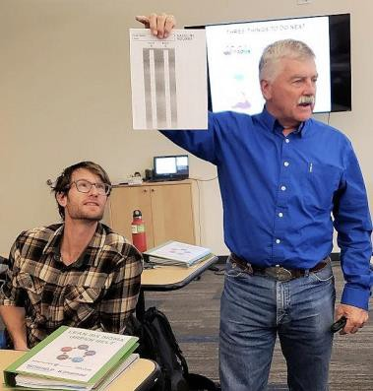
Dave O’Connell of Idaho State University leads a LSSGB session during a public workshop.

Our LSS Support Partners
- LSSGB Day 1 Class Session: “Define” Phase - Introduction to Lean, Six Sigma & Lean Six Sigma concepts. How to kick off your project with effective Problem Statements, a SIPOC map, Voice of the Customer, Charters, and data collection tips.
- LSSGB Day 2 Class Session: “Measure” Phase - How to measure process performance and determine two important aspects of any process, capability, and stability. An introduction to Standard Deviation, using histograms with upper and lower spec limits, using Control Charts, and understand Common vs Special cause variation in a process. The course uses QI macros software (an Excel add-on) to make this all easy.
- LSSGB Day 3 Class Session: “Analyze” Phase - Discuss problem-solving and root cause analysis experience and give feedback and advice on alternative methods. Discuss common problems that are often encountered when collecting and analyzing data, and provide methods to avoid or minimize these problems. Introduction to basic statistical analysis tools, scatter plots and hypothesis testing, and in-class exercises to practice using these tools on sample data.
- LSSGB Day 4 Session: “Improve/Control” Phase - How to plan and implement successful Improvement events (Kaizen). Revisit the House of Lean, review the Lean tools – 5S, Visual Workplace, Standard Work, Kanbans and Two Bin Systems, Quality at the Source, and Mistake Proofing. How to sustain the improvements made with effective Leadership practices and statistical tools. How Teams work. Students will present where they are at on their project and their next steps to complete their project. Finally, there will be a course evaluation and then certificates will be provided for completed class & project work.

ROI for Individual and or Company
Real-world project work is a vital part of the LSSGB program. Listed below are some typical improvements generated by LSS projects.
